7.05.2020
Тема занятия: “Удивительный побег. История Эрнеста Чаклтона."

1.

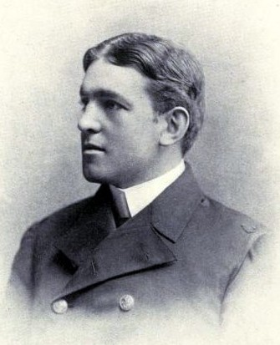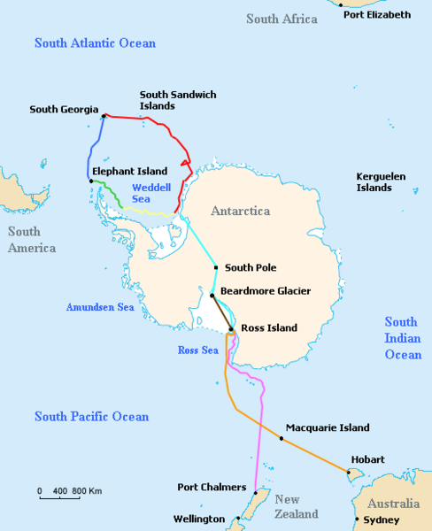

Ernest Shackleton was an Anglo-Irish explorer who is best known for his exploits at Antarctica during the early years of the 20th century. He was one of the key men who explored that region and was responsible for finding the route witch was used by first expedition who reached South Pole (Roald Admunsen, 1912).
He was born on 15 February 1874 in Kilkea, County Kildare, Ireland as a son of Henry Shackleton, landowner and a doctor. After finishing Dulwich College, he joined the Royal Navy at the age of 16. Shackleton sailed the seas on various naval merchant ships until the 1901 when he managed to convince several officers to be a member of "Discovery Expedition" fleet that was scheduled to visit Antarctic waters. During those times, they established a land camp and conducted several scientific experiments (first balloon flight over the ice and first use of the sledge dogs on Antarctic). Sadly, in 1903, his health becomes weakened by the cold weather and he was sent home by HMS Morning.
Four years later in 1907 Shackleton was chosen to be a leader in a new Antarctic expedition with a mission to explore deeper into continent. He reached the land on 29 January 1908 and after many delays, Shackleton started his land journey to south on 19 October. After three months on the road, they managed to come only 112 miles from the pole, but diminishing rations made them decide to turn back. In England Shackleton become true public hero, and on 12 July 1909, King Edward VII made him to be Commander of the Royal Victorian Order and a knight. In the following few years he shared his experiences from the Antarctica, and several of his peers used them in their journeys to the Pole in 1912.

Если возникли трудности,можно обсудить в приложении whatsApp(позвонить учителю).

